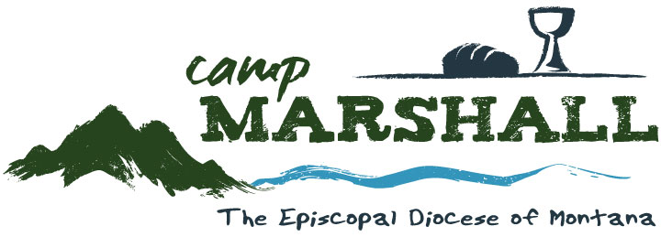
Camp Counselor Job Description
Camp Counselor
Counselors directly supervise campers and are responsible to lead groups of campers in daily camp activities. Counselors lead and motivate campers, and facilitate safe group interactions to foster campers’ social, spiritual, physical, and intellectual growth. Responsibilities include creating a strong and safe cabin community, giving attention to the needs of individual campers, supporting program staff in teaching activities during the day (including archery, arts & crafts, fishing, challenge course activities, watersports, field games, hiking, music, and possible overnight camping trips off site), and serving as a positive role model for campers. Counselors help to lead Bible Studies and small group reflection with campers during each camp session, and will help to lead worship at least once during each camp session.
Minimum Qualifications: • At least 18 years of age. • Desire and ability to work with children outdoors. • Willingness to work six days a week. • Willingness to supervise all aspects of assigned campers’ days, including wake-up, clean up, meals, rest time, evening activities, preparing for bed, overnight, and after-hours duties as assigned.
• Possesses maturity, integrity, adaptability, enthusiasm, sense of humor, patience, and self-control. • Willingness to assist in teaching program activities at camp. • Successful completion of staff training, and possession of current First Aid/CPR card.
• Willingness to participate in lifeguard training in order to obtain lifeguard certification. • Ability to plan, carry out, and evaluate camp programs. • Willingness to support the mission and ministry of Camp Marshall.
Specific Responsibilities: • Develop a personal relationship with each member of your cabin. Get to know each member of your cabin group and be available for their needs. Show interest in their lives, and in their likes and dislikes. • Write letters home for each camper on a weekly basis (in collaboration with program staff).
• Recognize and respond to opportunities for problem solving in your cabin group. • Assist program staff or chaplain as requested. • Help each cabin participant meet the goals established by Camp Marshall for our campers. • Be familiar with the daily camp schedule, and help your campers arrive on time to various camp activities. • Inform Assistant Director or Camp Director of any camper or staff problems, concerns, or issues.
• Help lead worship, program activities, camp songs, skits, and cabin devotions as assigned. • Supervise and participate in cabin clean up, meal hosting, and bathroom cleaning. • Perform other duties as assigned.
Responsible to: Camp Director or her designee Salary Information: Room and board, plus $200-$250 per week, depending on experience. Dates of Employment: June 1 - July 31, with the possibility of helping to facilitate day camps through mid August. Contact Jill Sallin, Administrative Assistant, 406-442-2230, ext 100, admin@diomontana.com

